**Glacio-Hydrological Degree Day Model Manual**

Contents

General requirement for Glacio-hydrological Degree-Day Model (GDM): 1

Anaconda Distribution: 1

Installing PCRaster: 2

Other necessary libraries: 2

Running the GDM model 3

Step 1: Open your GDM model folder. 3

Step 2: Data Preprocessing 3

Step 3: Input Map files 6

Step 4: Discharge Measurement Location 8

Step 5: Preprocessing 9

Step 6: Input parameters 9

Step 7: Run GDM 11

# General requirement for Glacio-hydrological Degree-Day Model (GDM):

## Anaconda Distribution:

You can install the Anaconda distribution by following these steps:

1. Go to the Anaconda website at https://www.anaconda.com/products/individual and download the appropriate version for your operating system (Windows, macOS, or Linux).
2. Once the download is complete, run the installer and follow the prompts.
3. During the installation process, you will be asked to select whether you want to install Anaconda for all users or just for your user account. Choose the option that best suits your needs.
4. You will also be asked to select a destination folder for the installation. The default location is usually fine, but you can choose a different location if you prefer.
5. Once the installation is complete, you can launch the Anaconda Navigator, which is a graphical user interface that allows you to manage your Anaconda environments and packages. You can also use the Anaconda Prompt, which is a command-line interface that allows you to run Python commands and manage your environments and packages from the command line.

## Installing PCRaster:

After setting up Conda you can create a new environment and install PCRaster. To do that:

1. Open Anaconda Prompt
2. Type the following code:   
   conda create --name pcraster -c conda-forge python=3.10 numpy pcraster campo lue matplotlib-base spyder spotpy qgis
3. Hit enter

you can reference the PCRaster website for more information:

[Installing PCRaster with Conda — PCRaster 4.4.0 documentation (uu.nl)](https://pcraster.geo.uu.nl/pcraster/4.4.0/documentation/pcraster_project/install.html)

## Other necessary libraries:

After installing PCraster, make sure these following libraries are also installed in the same environment where PCraster is installed.

1. numpy
2. pandas
3. netCDF4

Here are the instructions to check if the libraries are already installed and install them if not:

1. Activate pcraster environment.
2. To check if these libraries are already installed, open a Python interpreter (eg: jupyter notebook) or a command prompt and type the following commands:

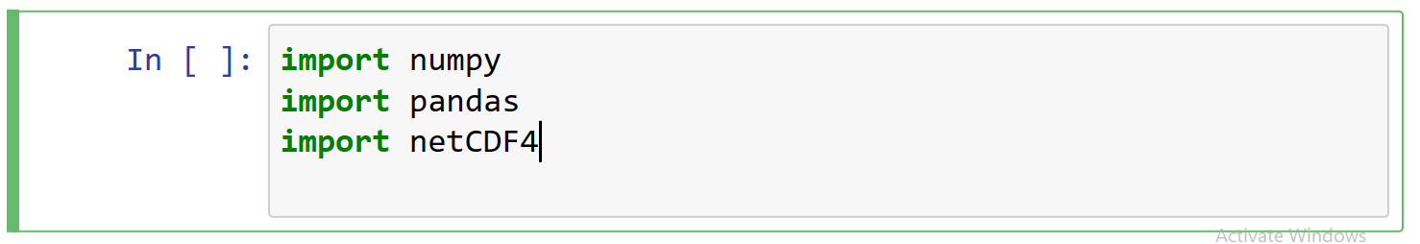

Fig: Necessary libraries

1. If you get an ImportError for any of these libraries, it means that the library is not installed. To install these libraries, you can use the following command:

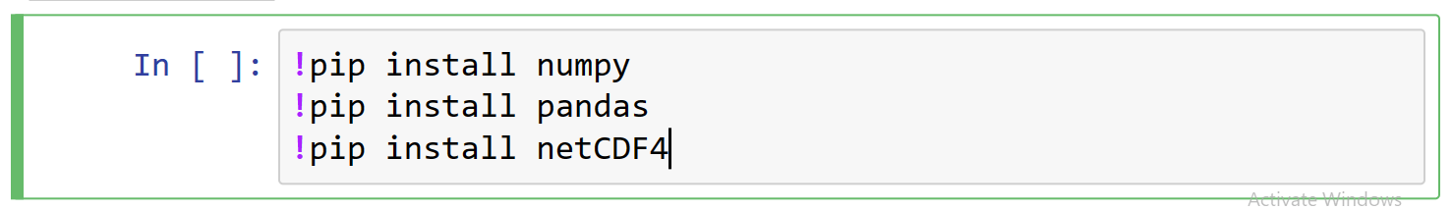

Fig: Installing necessary libraries

# Running the GDM model

## Step 1: Open your GDM model folder.

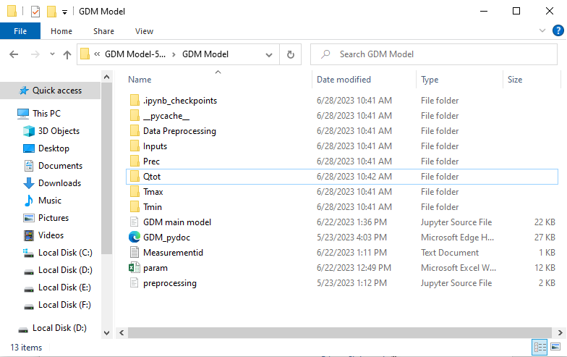

Fig: GDM main folder

Create Qtot,Prec, Tmax and Tmin empty folder in case you do not have them already.

## Step 2: Data Preprocessing

Go to “Data Preprocessing” folder. If the input data is from GCM model then go to “Netcdf Data” folder, else go to “Observed Station Data” folder.

Step 2.1: Load your precipitation, Maximum temperature and Minimum temperature data into “Netcdf Prec”, “Netcdf Tmax” and “Netcdf Tmin” folder respectively.

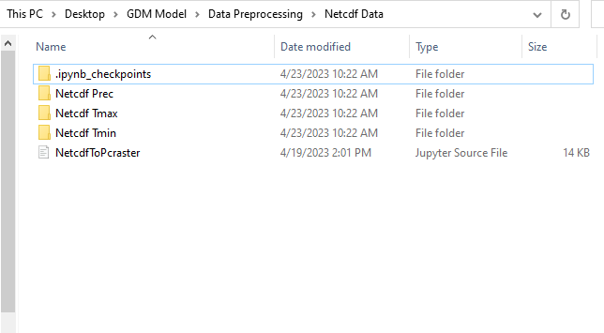

Fig: Subfolders for netcdf data

After the Data is Loaded into the respective folders, open the jupyter notebook file named as “NetcdfToPcraster”.

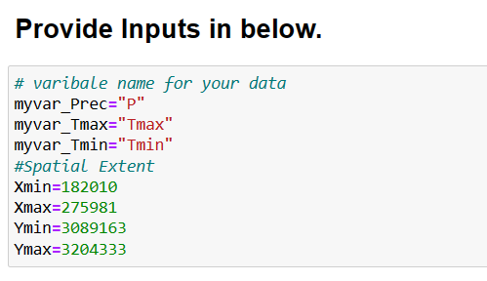

Fig: Necessary inputs for converting netcdf file to pcraster map format.

Inside the notebook, provide inputs as shown in the image above.

* **Spatial Extent**: Enter the spatial extent of your study area. This will ensure that the analysis is only performed on data within the specified area.
* **myvar_Prec**: Enter the variable name for precipitation as stored in the Netcdf data. In this case, it is "P". If you are using a different dataset, check the variable names and enter the appropriate name.
* **myvar_Tmax**: Enter the variable name for maximum temperature as stored in the Netcdf data. In this case, it is "Tmax". If you are using a different dataset, check the variable names and enter the appropriate name.
* **myvar_Tmin**: Enter the variable name for minimum temperature as stored in the Netcdf data. In this case, it is "Tmin". If you are using a different dataset, check the variable names and enter the appropriate name.

After providing the inputs just run the cells below. Processing time will depend on the amount of data and extent of the study area and resolution. Once the processing is finished you can check the “Prec”,”Tmax”, “Tmin ” subfolders inside main folder for the resultant data in the desired resolution and format. Resolution will be based on resolution of the “mask.map” file in the “Inputs” folder. Format will be Pcraster timeseries maps as required by GDM model.

**Note:** Skip step 2.1 if you are using observed input data from meteorological Stations.

Step 2.2: Go to “Observed Station Data folder” and Open “Station Data.xlsx” file.

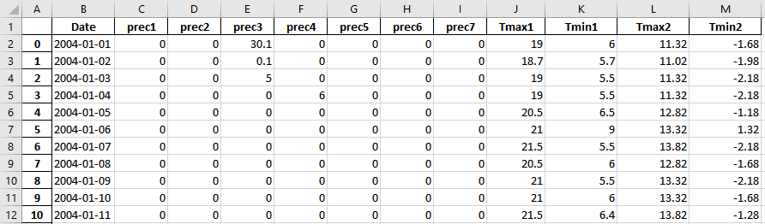

Fig: Showing input data storing method for precipitation and temperature for converting the observed data to pcraster map format.

If you have precipitation data for four meteorological stations within your study area, you can use the column names "prec1", "prec2", "prec3", and "prec4" to store the data in the “Station Data.xlsx” file. If you have data for additional stations, you can add more columns with names such as "prec5", "prec6", "prec7" etc. “Tmax1” and “Tmin1” are the temperature station data at lower elevation and “Tmax2” and “Tmin2” are the temperature station data at higher elevation. If you have multiple temperature station data use only two stations, one with the lowest elevation and other with the highest elevation. Now open “stationid.txt” file inside “Observed Station Data” and store location coordinates for precipitation stations in the similar order as you have stored precipitation data in the “Station Data.xlsx” excel file. A sample is shown below:

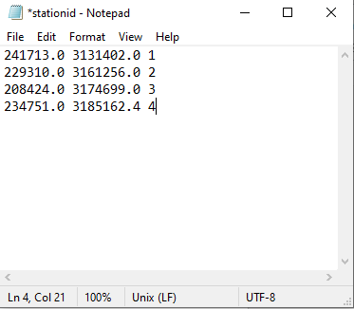

Fig: Text file storing location for different precipitation stations.

Finally, open “Observed Station data interpolation” jupyter notebook file and run the script. The resultant input data will be loaded in “Prec”,”Tmax”, “Tmin” subfolder inside the main folder.

**Note**: Names of the columns in the “Station Data.xlsx” file should be according to the instruction above.

**Note:** If the input meteorological data is from Global climate model in Netcdf format, Skip step 2.2 and go to step 2.1.

## Step 3: Input Map files

Step 3.1: Open subfolder named as “Inputs” inside the main folder and load elevation, land use and mask file of your study area in pcraster map format. Use this link for instruction to convert geotiff to pcraster format:  
[GeoTIFF to PCRaster](https://youtu.be/7nSh-93z3Ro)  
Sample Map files are shown below for Marsyandhi river Basin.

DEM:  
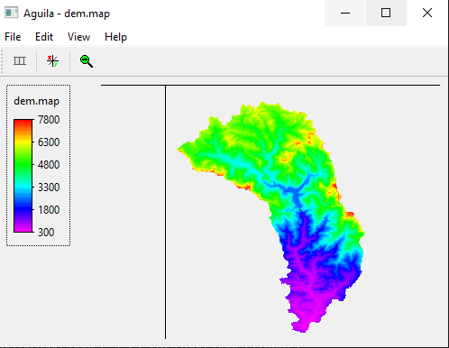

Fig: Showing elevation map.

Land use:

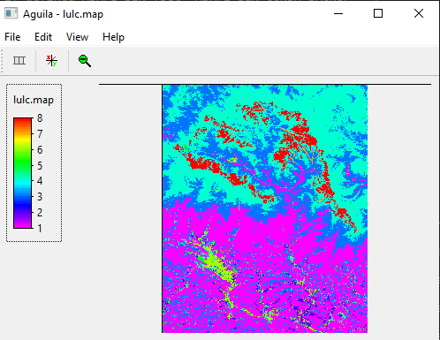

Fig: Showing land use map

Provide full extent for land use file.

Mask:  
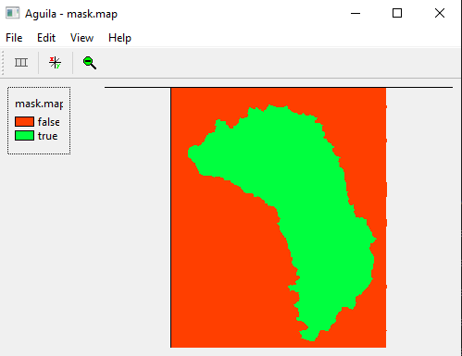

Fig: Showing mask map.

## Step 4: Discharge Measurement Location

Open “Measurementid.txt” file inside main folder and add co-ordinates for the location from where you want your output data to be extracted. A Sample is shown below:

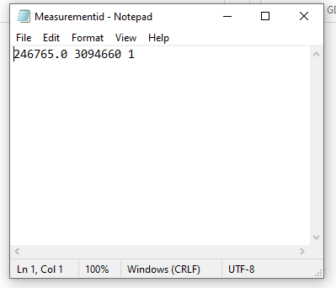

Fig: Text file for measurement location.  
  
If you are extracted output from multiple location provide coordinates for multiple location as shown below:

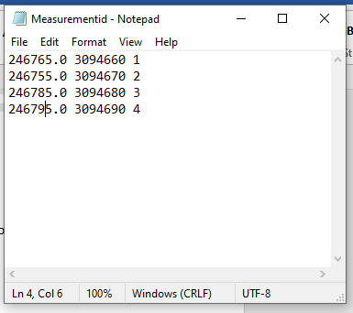

Fig: Text file for multiple measurement location.

## Step 5: Preprocessing

Open jupyter notebook file named as “preprocessing” and run it. I will create a pcraster map with location coordinates.

## Step 6: Input parameters

Open excel file named as “params” and input the required parameters. There are two excel sheets named as “param1” and “param2”. Input needs to be provided in both the excel sheet as shown below:

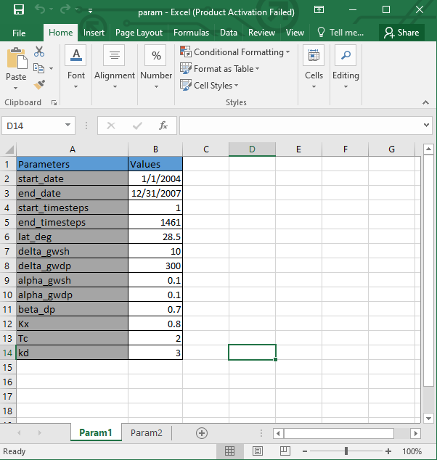

Fig: Showing input parameters for excel sheet 1.

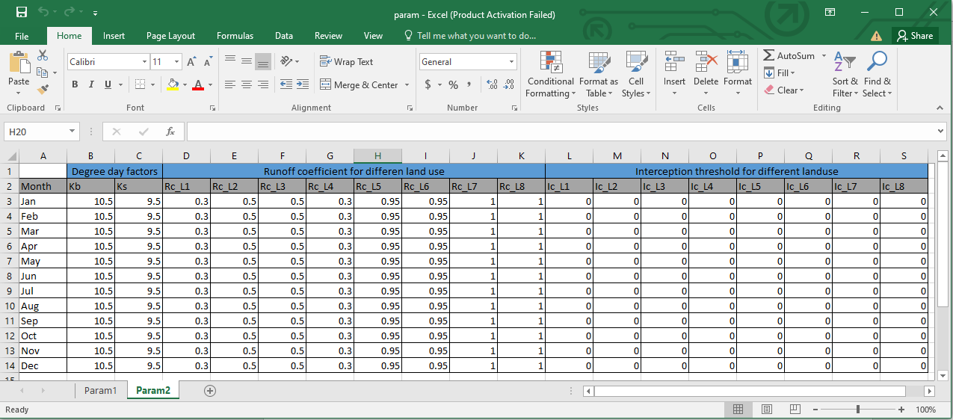

Fig: Showing Input parameters for excel sheet 2.

Information about the different inputs variables is listed below:

**start_date**: starting date of your input precipitation and temperature data

**end_date:** ending data of your input precipitation and temperature data

**start_timesteps**: starting time step of your precipitation and temperature data

**end_timesteps**: ending time step of your precipitation and temperature data

**lat_deg**: latitude in Geographical coordinate system at the centroid of your study area.

**delta_gwsh**: is the delay time of the overlying geologic formations (days).

**delta_gwdp**: is the delay time or drainage time of the deep aquifer geologic formations (days).

**alpha_gwsh**: Recession constant for shallow aquifer.

**alpha_gwdp**: Recession constant for deep aquifer.

**beta_dp**: is a coefficient of shallow aquifer percolation to deep aquifer.

**Kx:** Recession coefficient for surface runoff.

**Tc:** Critical temperature

**kd**: Degree day factor for debris cover glacier.

**Kb**: Degree day factor for clean glacier.

**Ks:** Degree day factor for snow.

**Rc_L1, Rc_L2 …….. Rc_L8:** Runoff coefficient for landuse 1 to landuse 8.

**Ic_L1, Ic_L2 ……. Ic_L8**: Interception threshold for landuse 1 to landuse 8.

## Step 7: Run GDM

After completing all the above steps open “GDM main model” jupyter notebook file and run it. Resulting discharge maps will be saved in “Qtot” subfolder inside the main folder. Output for icemelt, snowmelt, rain, baseflow and discharge at the desired location will be saved in respective text file inside the main folder.